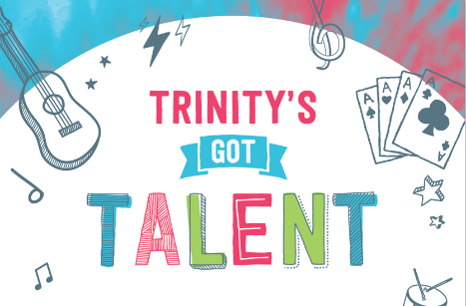
EXPRESSION OF INTEREST

Sunday 28 November 2021, 3pm - 7pm

Piazza Link Park Alkimos

Please return by Sunday 7th November 2021

Name of Association/Group/School/Individual Name _______________________________________________________________________________________

Category (Select): Dancing Music Singing Other

Group (Select): Primary School Age (5-12 years)
Secondary School Age (13-18 years)

OR

Individual (Select): Primary School Age (5-12 years)
Secondary School Age (13-18 years)
Adult (18 +years)

Title of performance: ______________________________________________________________________

Brief description of performance:____________________________________________________________
_______________________________________________________________________________________
_______________________________________________________________________________________

Length of performance: __________________ (minutes) (Please note: 5 mins maximum)
Number of performers: __________________

Technical requirements: Microphones, music stands etc
_______________________________________________________________________

NOTE: Please send us a short video that we can use for the selection of performers. The aim is to have as many different acts as possible. The event organisers will contact you in due course to confirm acceptance/decline of your application.

Contact details
Name: _______________________________________________________________________________________

Mobile: _____________________________________________

Email: ________________________________________________________________________________

Post code:_____________________

Signature: ______________________________________ Date:__________________________________

Please note: 1. Responsibility for the performers during the event rests with the above person.
2. The signatory gives permission for images/video taken be used for any publicity.
Please email to Event Managers: trinitytalent@eventsperth.com.au
Office phone: 9328 6829

